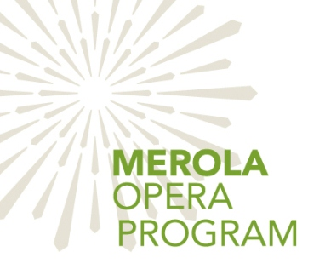
Merola Opera Program
2020
Student ConneXion
Application
Deadline: 5.11.20
Name: _____________________________________________________________
Email: _____________________________________________________________
Mailing Address:_____________________________________________________
City: ______________________________________ Zip Code: ________________
Phone: ____________________________________________________________
School: ____________________________________________________________
Grade Level:________________________________________________________
Why would you like to be a part of the Merola Student ConneXion Program?

Please send completed application to hli@merola.org or Merola ConneXion Program, 601 Van Ness Avenue, Suite S, San Francisco, CA, 94102
The Merola Student ConneXion Program provides selected junior high, high school, and college students with free access to various Merola Opera Program events and performances June – August 2020 in San Francisco. Accepted students will receive:
• Up to two (2) tickets to observe various Merola master classes in June, July, and August at the Herbst Theatre.
• Up to two (2) tickets to these final dress rehearsals of Merola summer productions:

Tuesday, July 7, 6:00 pm Schwabacher Summer Concert
Presidio Theatre
Tuesday, July 21, 6:00 pm Postcard from Morocco
Presidio Theatre
Tuesday, August 4, 4:00 pm Le nozze di Figaro
Presidio Theatre

Plus, two (2) performance tickets for:

Saturday, August 22, 7:30 pm Merola Grand Finale
War Memorial Opera House

Applications will be reviewed by the Merola ConneXion Advisory Committee.
Deadline to apply is May 11th. Selected students will be contacted by email.

Participation Requirements

Must be currently enrolled student with valid school ID.
A copy of your student ID and/or proof of enrollment will be requested for admission.
Accepted students must attend a mandatory ConneXion orientation on
Wednesday, June 17, at 6:15 pm, at the Herbst Theatre.
Please do not apply if you cannot attend.
Attendance at five (5) Merola events/performances is required to maintain membership. You are provided with up to two tickets for each event – one must be used by the ConneXion member. Selected participants 18 years and younger will be required to submit a parental approval agreement (provided upon admission).

Please send completed application by May 11th to:

Merola ConneXion Program
601 Van Ness Avenue, Suite S
San Francisco, CA 94102
or by email to Hilda Li at hli@merola.org

The Merola Student ConneXion Program does not offer any kind of training or artistic studies.

